**STRING METHODS :**

**1.charAT:** *Returns characters from the string based on Index value.*

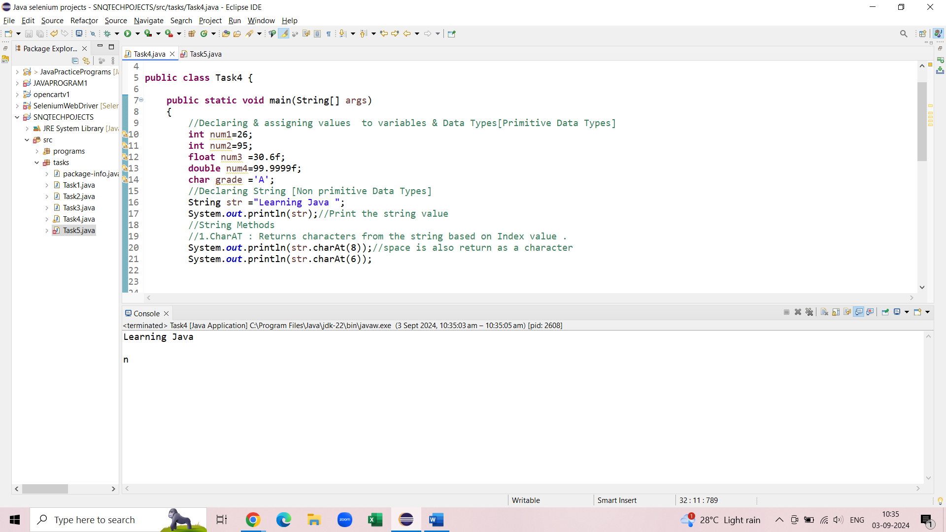 **2.compareTo:** *Compare two strings and*

* *return "0"If both the strings are equal*
* *return value lesser/greater value than 0 if string is Unequal*

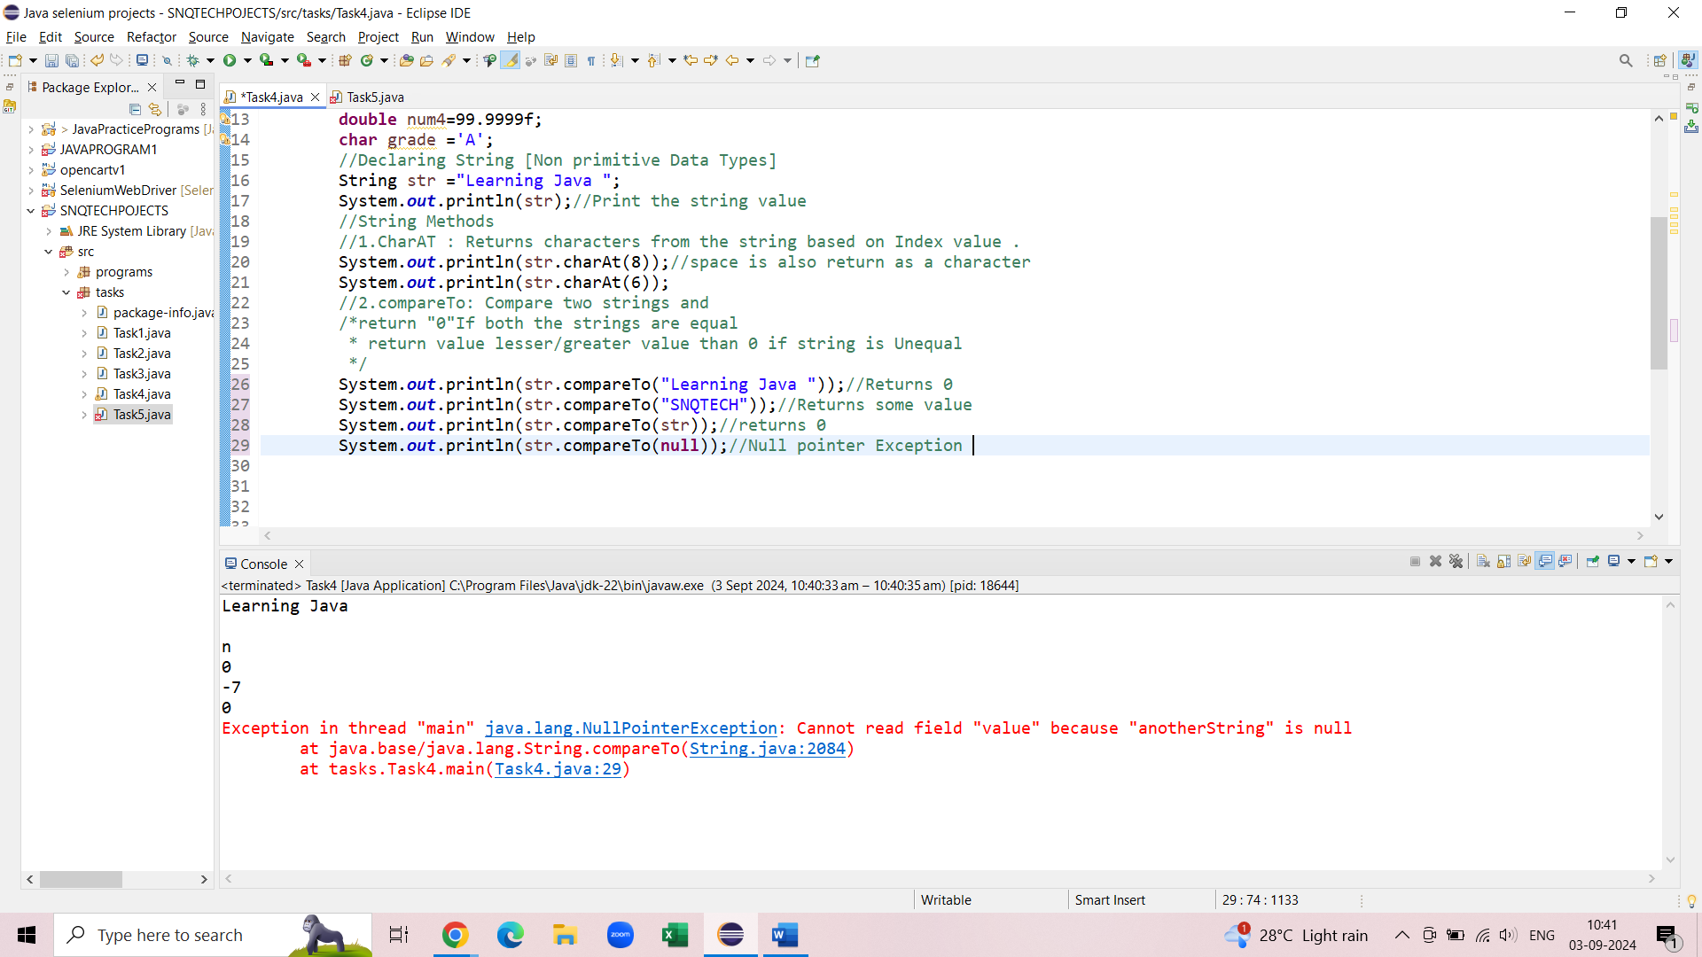

**3.compareToIgnoreCase:** *compare two strings by ignoring cases (lower case /upper case)*

* *return "0"If both the strings are equal*
* *return value lesser/greater value than 0 if string is Unequal*

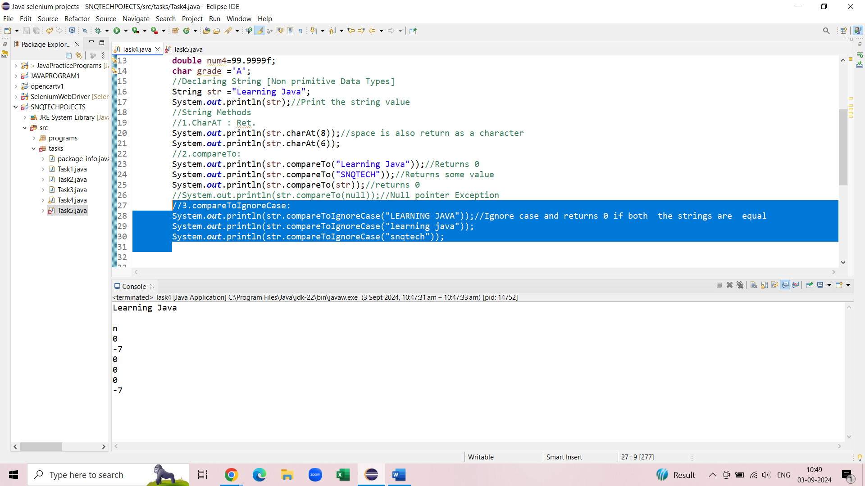

**3.** **4.equals():***Checks two string and return true if both strings are equal else returns false*

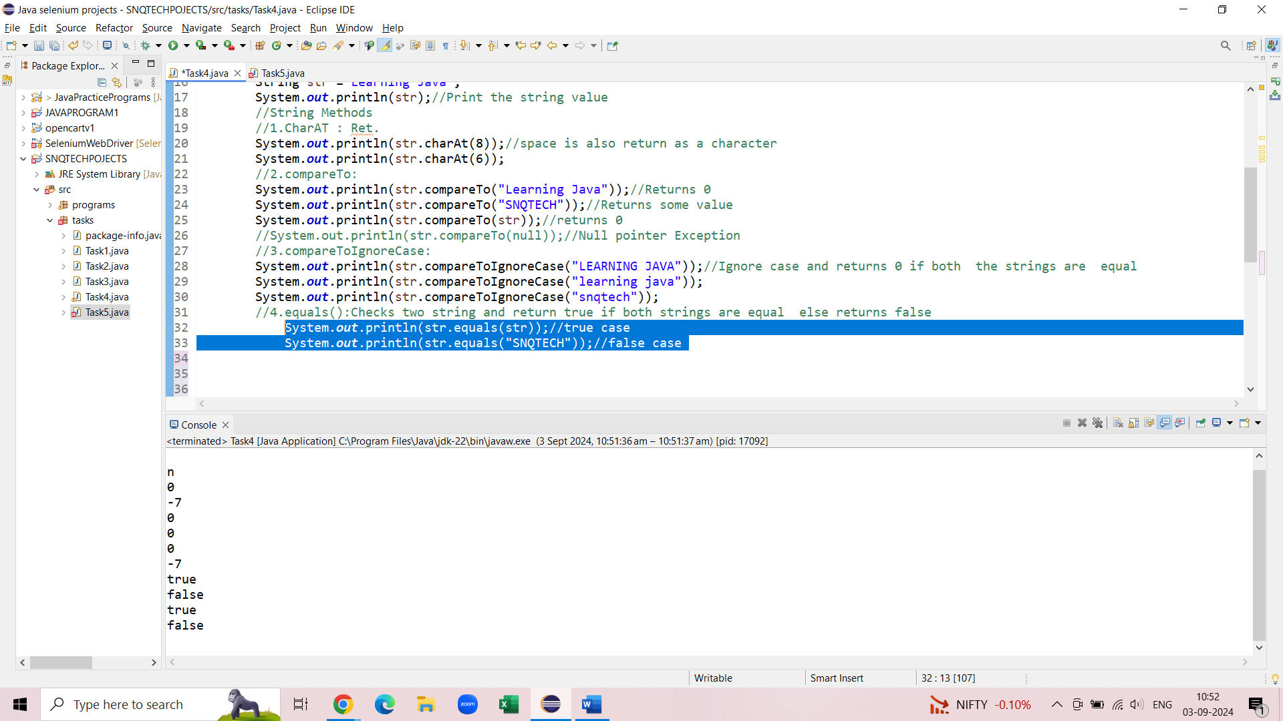

**5.equalsIgnoreCase:** *Checks two string and return true if both strings are equal else returns false by ignoring lower & upper cases*

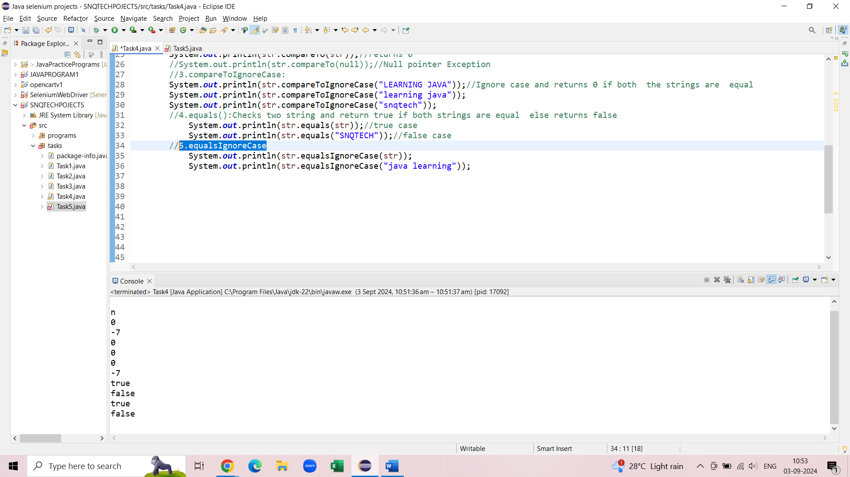

**6.toLowerCase: *converts the characters of the string to lower case***

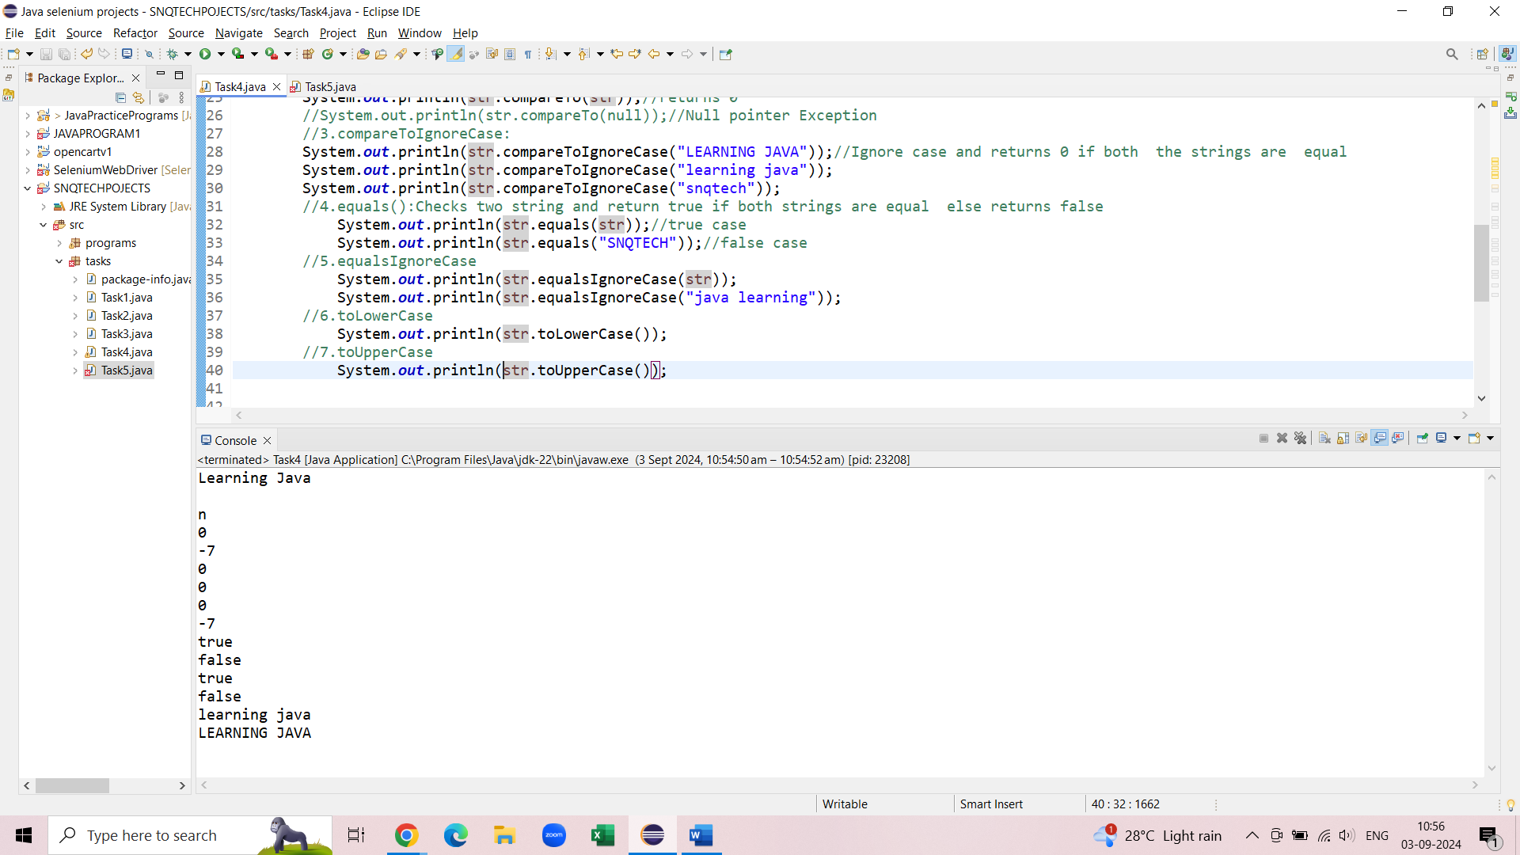

**7.toUpperCAse : *Converts the characters of the string to upper case .***

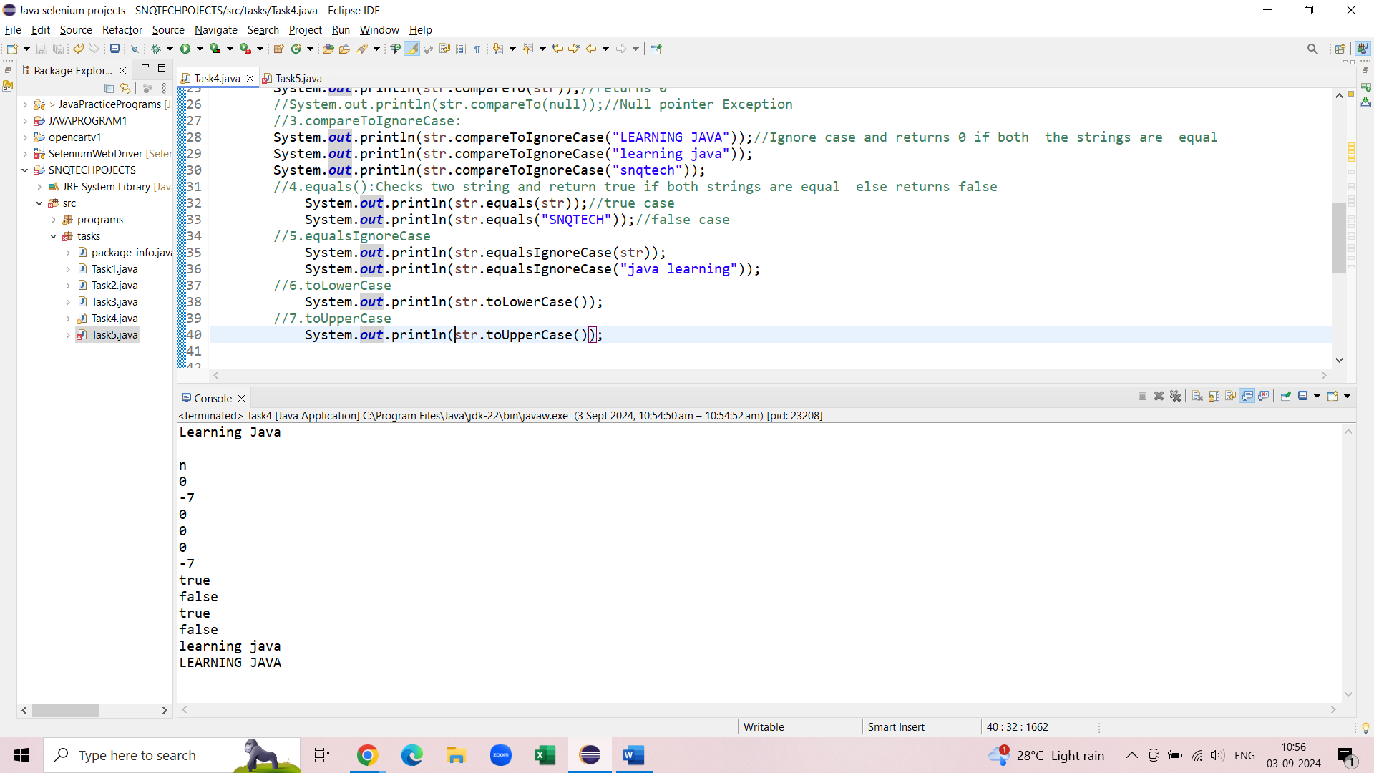

**8.concat :** *Concatenates the specified string to the end of this string.*

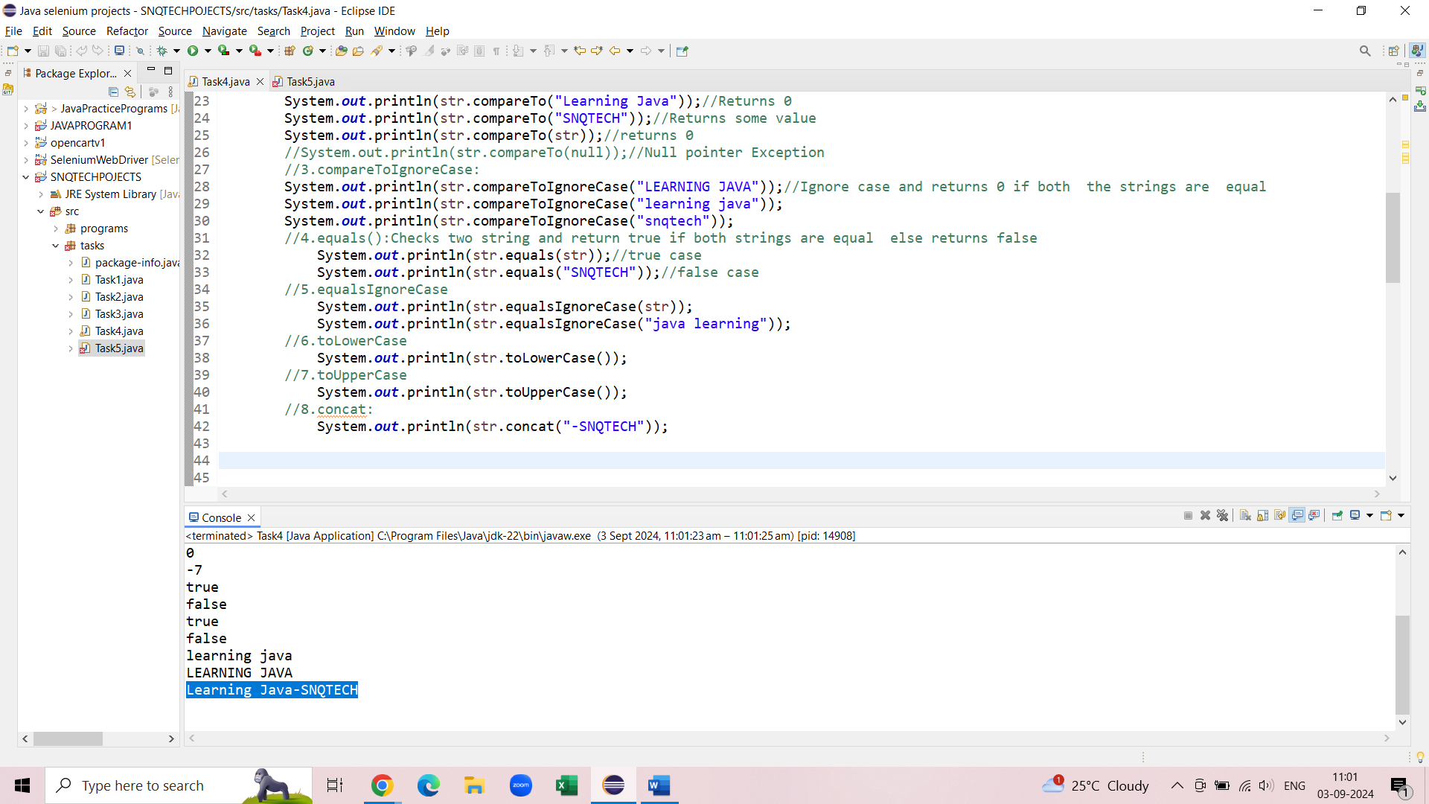

**9.** **contains:** *Returns true if and only if this string contains the specified sequence of char values.*

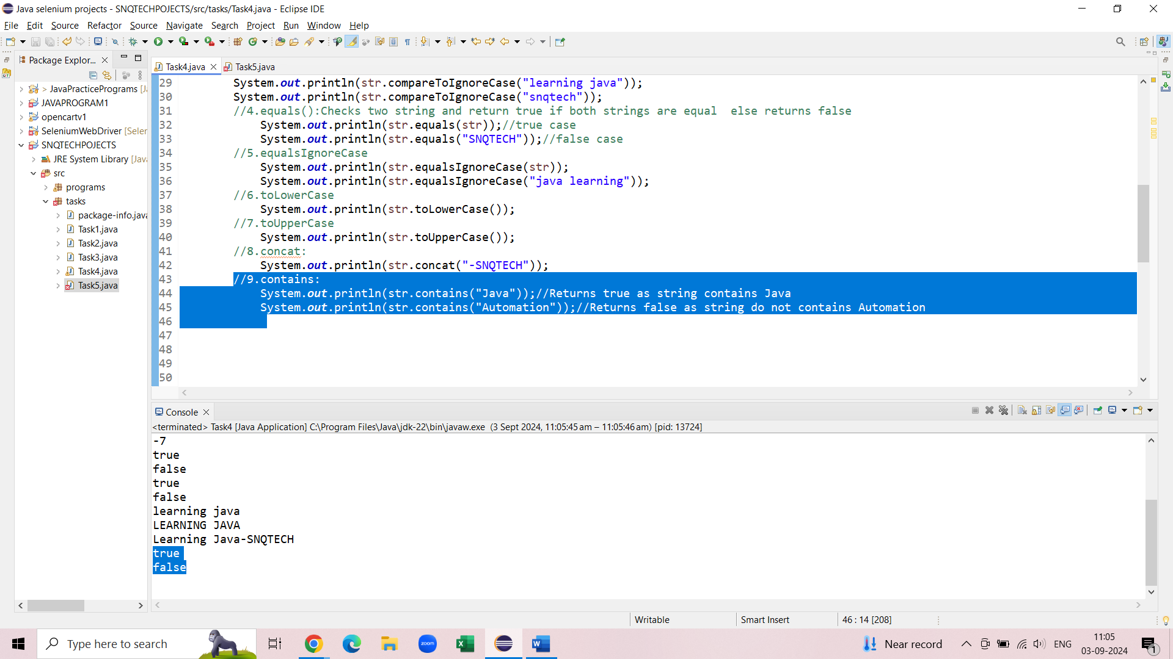

**10.length:** *the length of the sequence of characters represented by this object.*

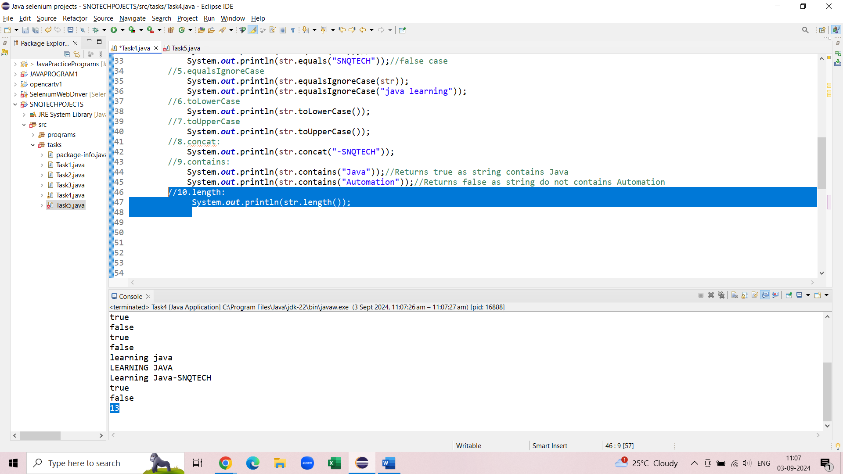

*11* **startsWith():***Tests if this string starts with the specified prefix.*

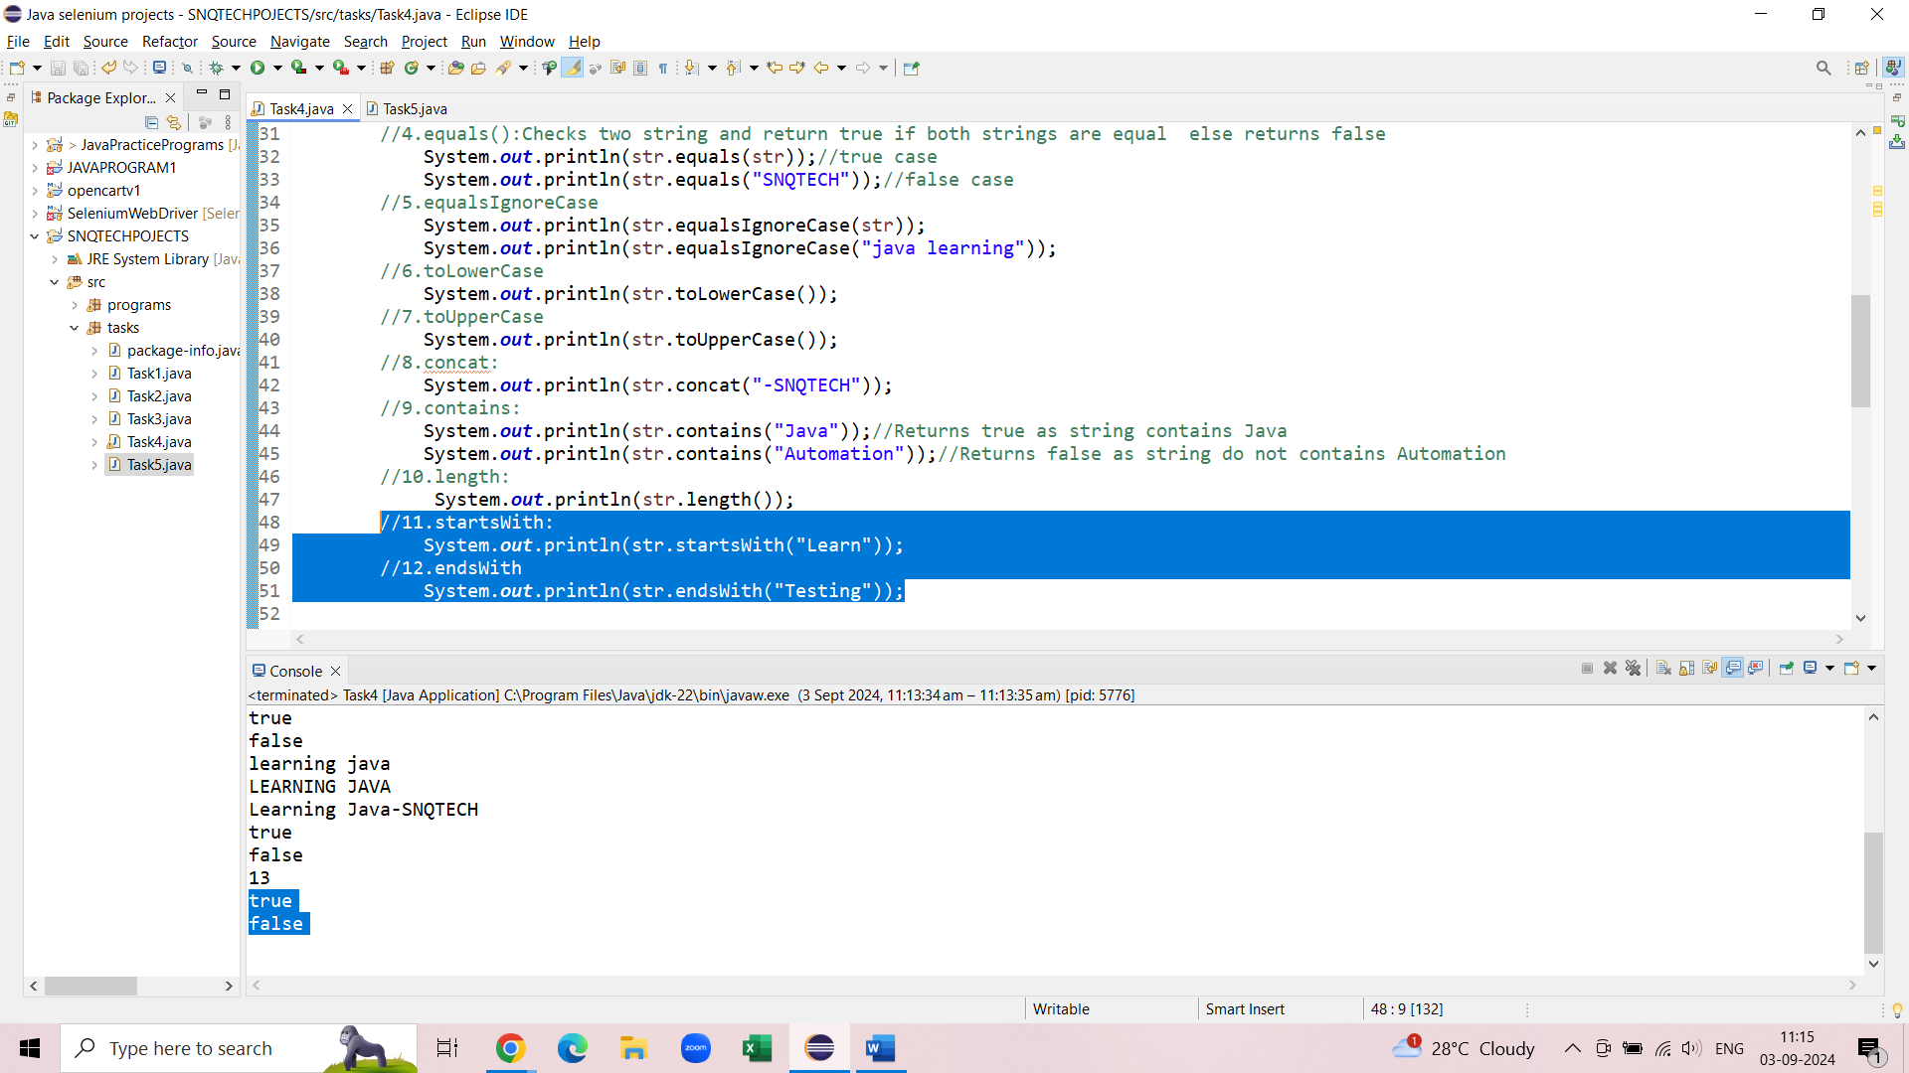

**12.** **endsWith():** *Tests if this string ends with the specified suffix.*



**13.** **replace:** *Replace part of string with other string*

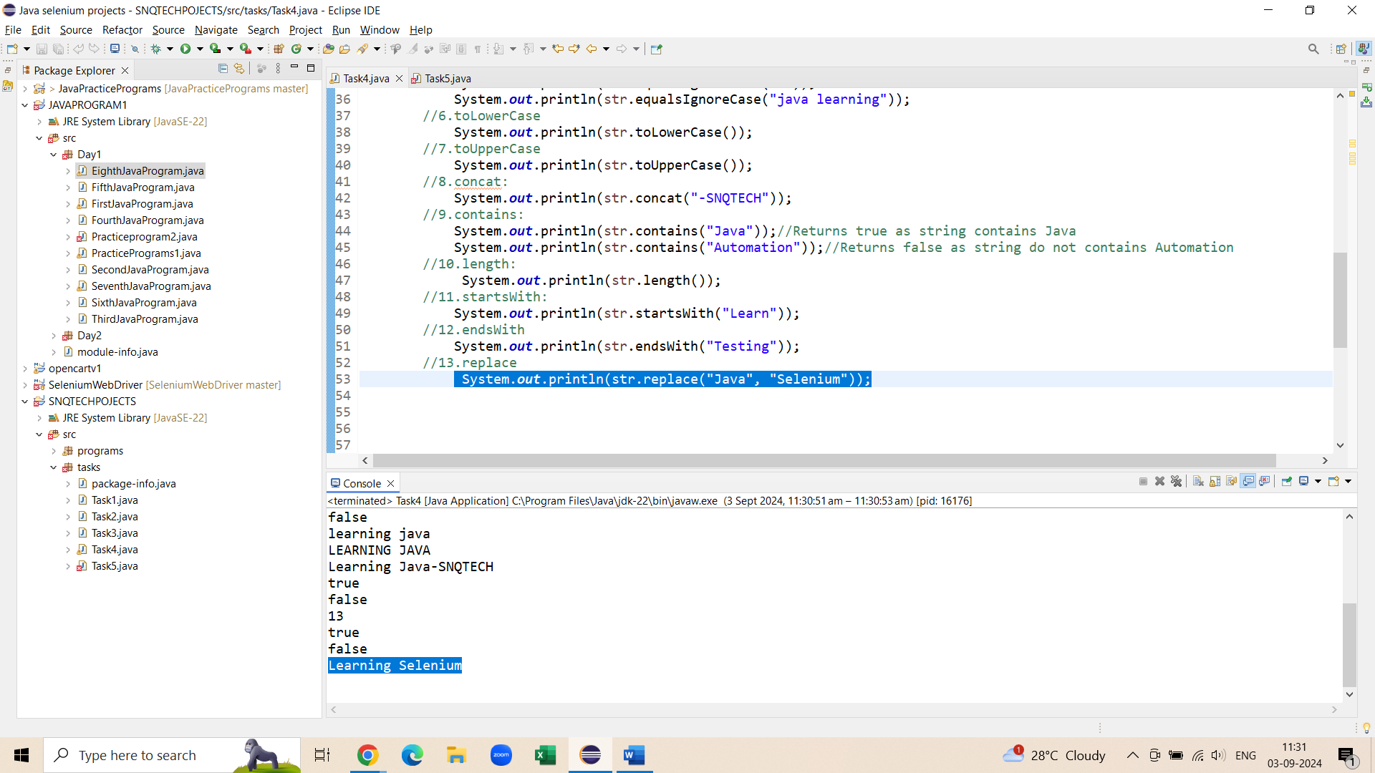

**14.** **replaceAll:** *Replace whole string with other string*

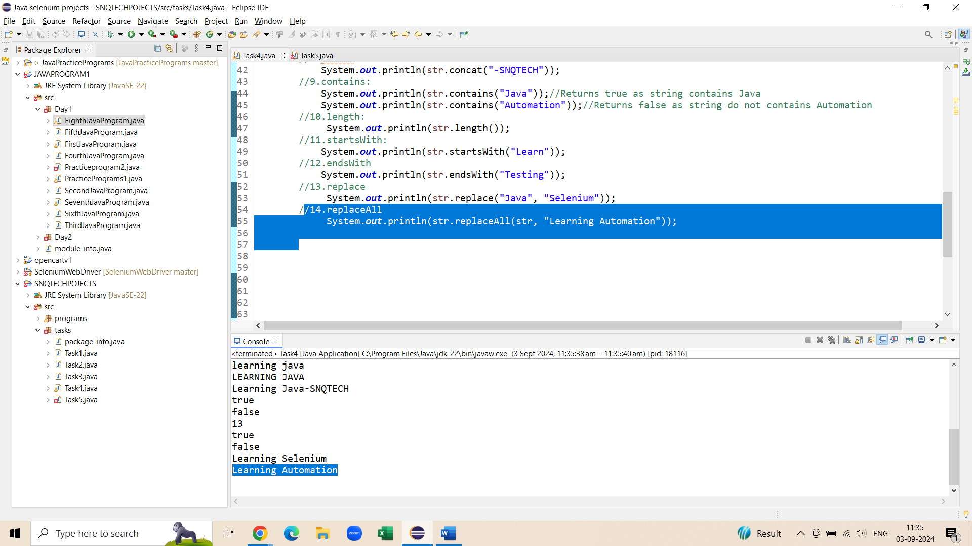

**15.** **isBlank:** *checks if the string has no value and*

* *returns false if the string has value assigned*
* *returns true if the string has no value assigned*

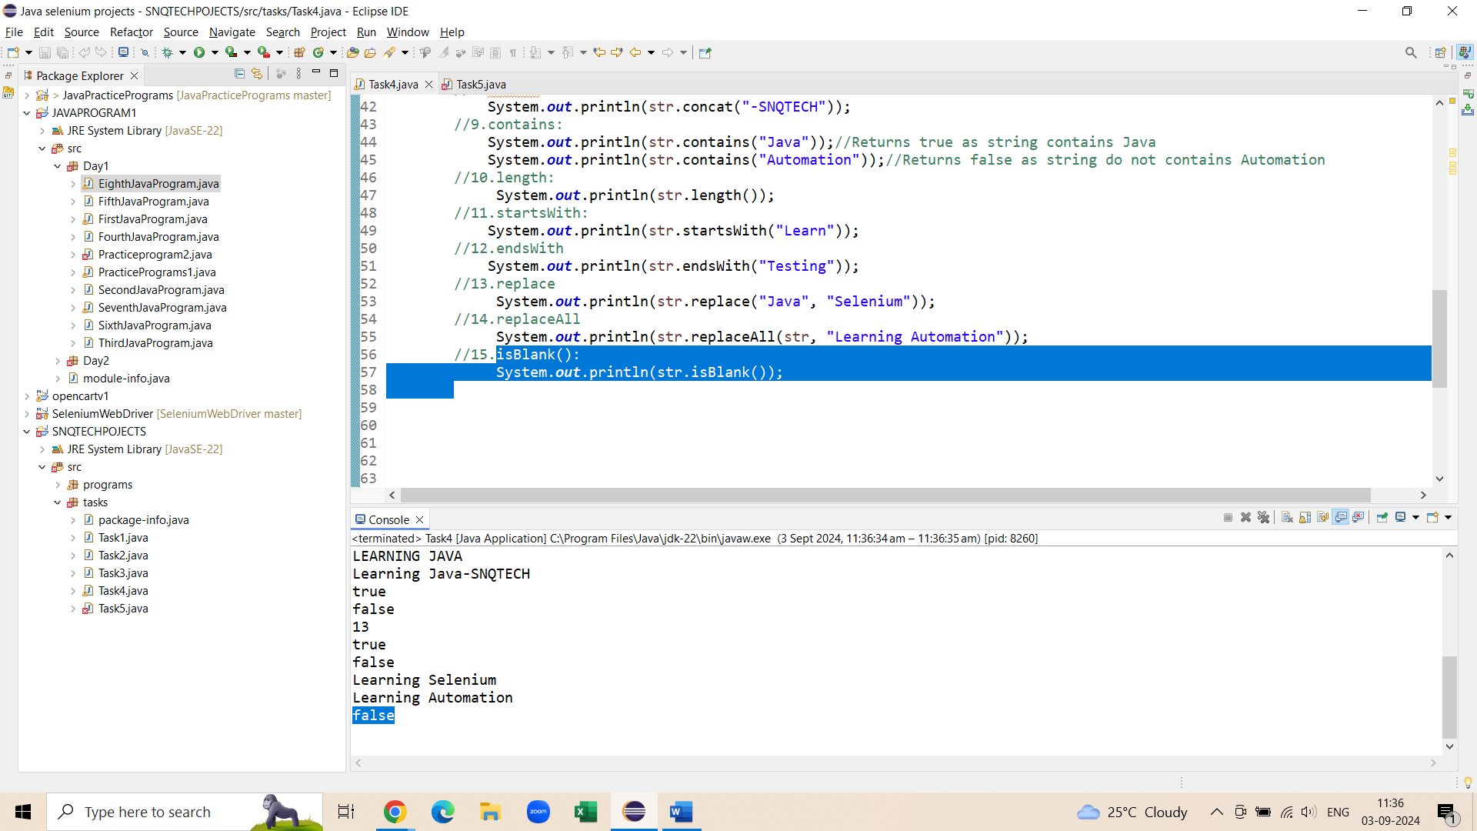

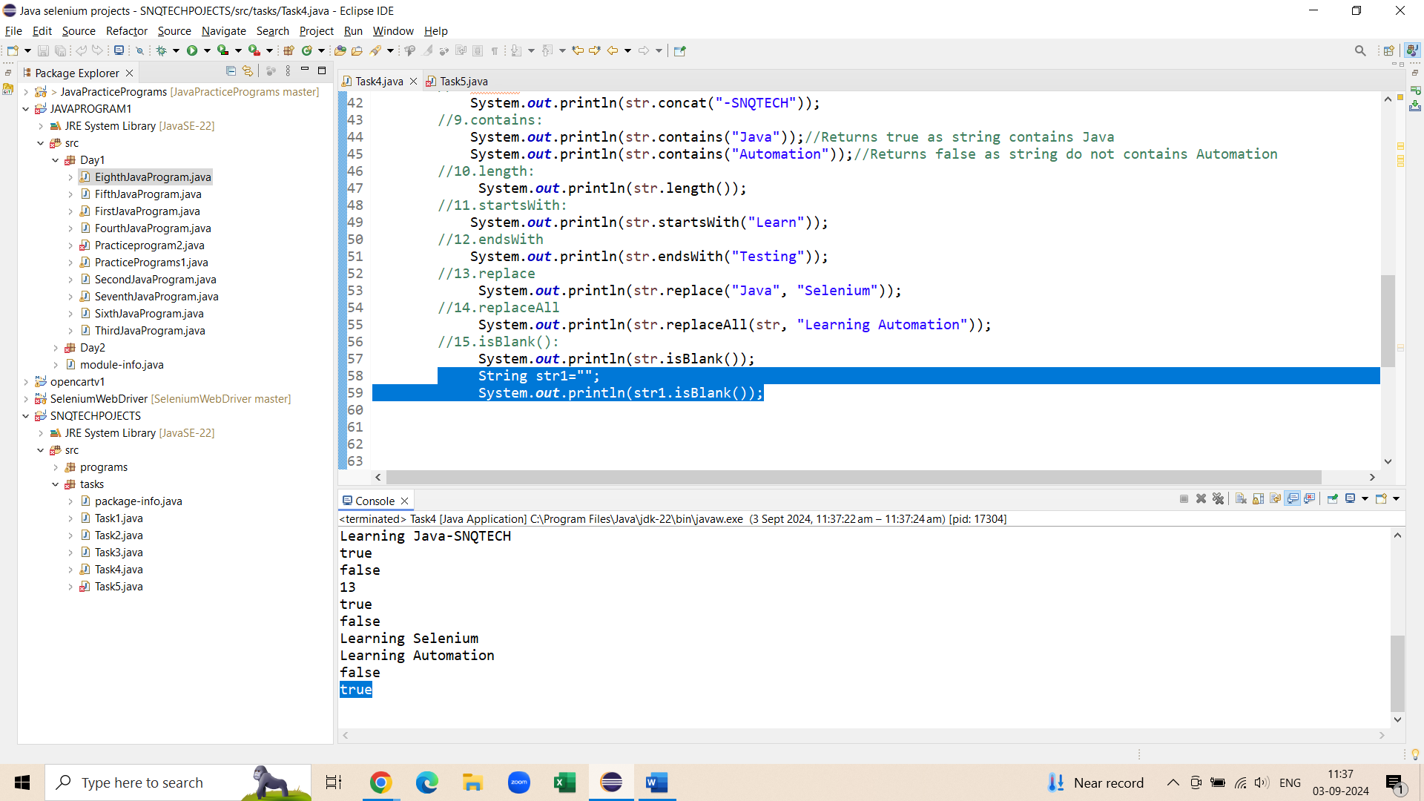

**16.** **isEmpty: It checks the length of the string and**

* *returns true if the length of the string is 0*
* *returns false if the length of the string is value>0*

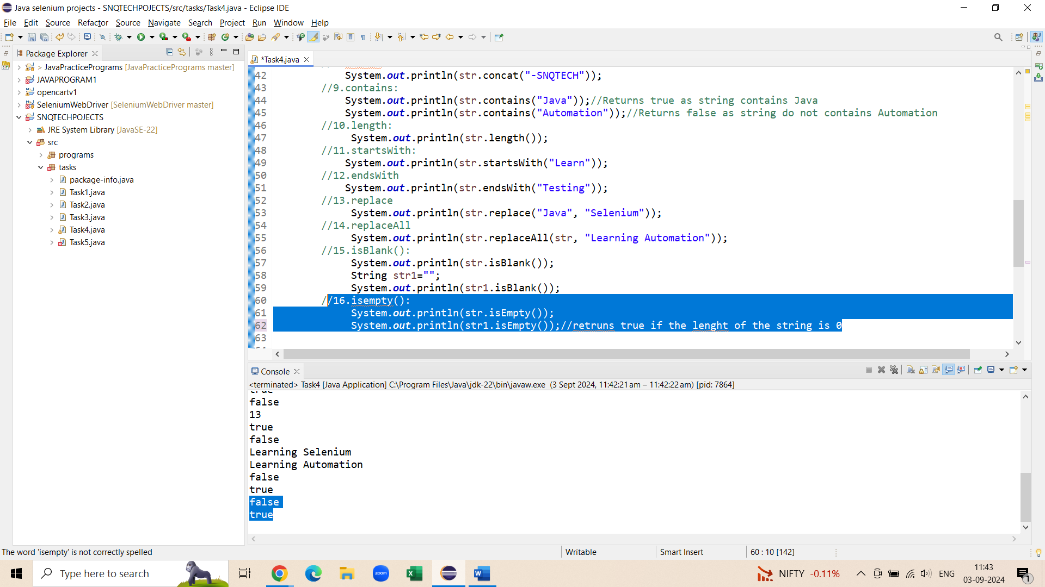

**17.toString():**

**18.trim().:** *It removes Unwanted spaces from the string*

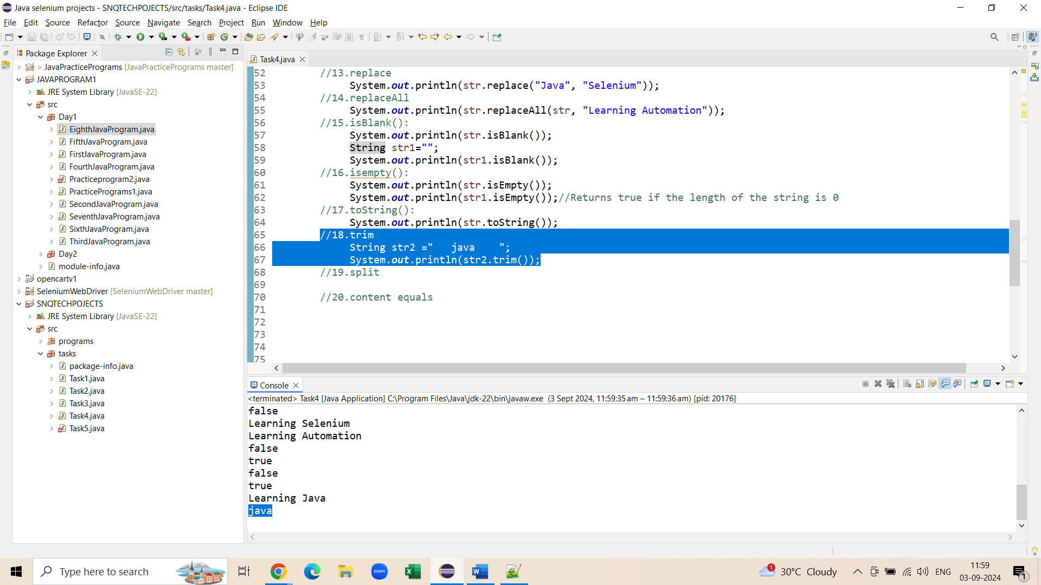

**19.split():**

**20.contentequals():**

